Business Requirements Document

Project name: Integrated Hospital Management System

Project Overview
This project aims to enhance both patient experience and operational efficiency within a multi-specialty hospital by implementing an integrated Hospital Information System (HIS). The current environment is affected by appointment scheduling issues, system inefficiencies, and limited user-friendliness, which impact overall service quality.

The proposed solution includes the development of a cloud-based system to centralize appointment data, patient records, and scheduling information. This system will enable real-time access to doctor availability, eliminate duplicate bookings, and ensure secure and reliable data storage.

Additionally, the project focuses on improving communication between stakeholders, optimizing resource allocation, and enhancing equipment utilization to ensure faster processing of lab results, even during peak hours. A user-friendly interface will be designed to support patients of all age groups, along with 24/7 support services to assist with appointment and system-related queries.

The expected outcomes include reduced waiting times, elimination of overbooking, improved accuracy in scheduling, faster diagnostic results, better visibility into resource usage, and enhanced patient satisfaction through a more efficient and accessible system

Background and Problem Statement
Background

The hospital currently operates using multiple standalone systems for appointment scheduling, patient record management, and departmental coordination. These systems are not fully integrated, and several processes, including communication between departments and patient updates, rely on manual or semi-digital methods.

The existing online appointment system is not user-friendly, making it difficult for certain patient groups, especially elderly patients, to book and manage appointments. Patient records are maintained in outdated systems, making navigation and retrieval time-consuming during consultations.

Additionally, communication across departments such as emergency, ICU, radiology, and general wards lacks a streamlined process, and resource tracking for staff, equipment, and supplies is not centrally managed. The hospital also experiences network instability and relies on legacy systems with potential security risks.

Problem Statement

The current system has led to significant operational challenges across the hospital. Appointment scheduling is inefficient, with frequent overbooking, double bookings, cancellations without timely notification, and lack of real-time updates to patients. This results in long wait times, often exceeding 30–60 minutes, and increased patient dissatisfaction.

There are critical communication gaps between stakeholders, particularly during patient transfers between departments such as emergency, ICU, and wards, leading to delays, duplication of efforts, and lack of visibility into patient status and bed availability. Doctors also face delays in receiving lab and radiology results, and limited access to patient progress updates, affecting diagnosis and follow-up care.

Resource management is inconsistent, with limited availability of essential supplies, uneven nurse-to-patient ratios, inadequate staffing during peak times, and restricted access to equipment and operating rooms.

From a system perspective, the lack of integration between scheduling and record management has created data silos, resulting in delays in retrieving patient information and inconsistencies in billing. The system also suffers from network downtime, poor user interface design, and security vulnerabilities in legacy platforms.

These issues collectively reduce operational efficiency, impact quality of care, and lead to poor patient experience

Project scope
In-scope  - Implementation of an Integrated Hospital Information System (HIS)  - Centralized Electronic Health Records (EHR) for patient data  - Appointment scheduling system with real-time doctor availability and overbooking prevention  - Operating room availability tracking to support scheduling and avoid conflicts  - Lab/Radiology results integration for timely access to diagnostic reports  - Automated notifications (SMS/Email) for appointments, delays, and cancellations  - Resource management module to track availability of medical supplies and equipment  - Interdepartmental communication system for patient status updates and transfers  - Billing integration with scheduling and treatment data | Out-of-scope  - Hiring or staffing changes (e.g., additional nurses for shifts)  - Physical infrastructure expansion (beds, rooms, hospital capacity)  - Procurement of new medical equipment  - Network infrastructure upgrades (assumed as existing support)

Stakeholders
- Patients
- Doctors
- Nurses
- Administrative Staff
- IT Team

Business objectives
- Improve appointment efficiency
- Reduce appointment conflicts, overbooking, and no-show rates by 30% through real-time scheduling and automated notifications.
- Enhance patient experience
- Increase patient satisfaction scores from 5–6 to 8+ by reducing wait times and providing timely updates and clear communication.
- Enable integrated data access
- Achieve 100% centralized access to patient records, lab results, and scheduling data to eliminate data silos and improve decision-making.
- Improve operational coordination
- Reduce interdepartmental communication delays by 40% through a unified system for patient status updates, referrals, and transfers.
- Optimize resource utilization
- Improve visibility and tracking of medical supplies, equipment, and operating room usage to support efficient allocation and reduce shortages.
- Ensure data accuracy and billing reliability
- Reduce billing discrepancies by 50% through integration of scheduling, treatment, and billing systems.

Requirements
Functional requirements  - System shall enable online appointment booking and prevent overbooking.  - System shall prevent duplicate appointments for the same patient at the same time.  - System shall show real-time doctor availability and categorize by specialization.  - System shall support appointment rescheduling, cancellation, and updates in real time.  - System shall send real-time notifications (SMS/email/app) for bookings, delays, and cancellations.  - System shall integrate scheduling, billing, and patient records into a single HIS platform.  - System shall store and allow secure access to patient records in cloud storage.  - System shall ensure lab results are shared in real time with doctors and patients.  - System shall support inter-department communication (ER, ICU, labs, wards) and patient transfers.  - System shall provide real-time tracking of hospital resources (beds, ICUs, OT, equipment, consumables).  - System shall sync billing data with treatment records and ensure accurate billing.  - System shall provide analytics on patient trends, resource usage, and department performance.  - System shall allow quick retrieval of patient history even during peak hours.  - System shall support a structured referral system that is simple and user-friendly.  - * System shall ensure elderly patients can easily access support desk assistance (via simplified interface + assisted | Non-functional requirements  - System shall be fast and retrieve records within seconds even during peak load.  - System shall ensure high availability with minimal downtime (24/7 critical access).  - System shall be secure with role-based access control for patient data.  - System shall be scalable to handle increasing patients, staff, and departments.  - System shall ensure data consistency across all integrated modules (HIS, billing, scheduling).  - System shall be user-friendly for patients, staff, and especially elderly users.  - System shall ensure real-time data synchronization across departments.  - System shall support maintainability and modular upgrades.  - System shall ensure reliable inter-department communication with minimal delays.  - System shall maintain data backup and recovery for critical hospital information.

Assumptions
- It is assumed that the hospital management supports the adoption of a centralized Hospital Information System (HIS) covering appointments, billing, records, and resource management.
- It is assumed that existing patient, doctor, treatment, and scheduling data is available and can be digitized or migrated from legacy systems.
- It is assumed that all departments (cardiology, neurology, orthopedics, pediatrics, etc.) will participate in system integration and data sharing.
- It is assumed that real-time communication between departments (lab, radiology, ICU, ER, wards) can be enabled through system integration or digital workflows.
- It is assumed that resource allocation data (beds, operation theatres, ICUs, and medical equipment) can be tracked and updated in real time.
- It is assumed that hospital staff will adapt to improved digital workflows with adequate training and onboarding support.
- It is assumed that patients will gradually adopt digital services, while alternative assisted support (support desk/manual booking) will remain available for elderly users.
- It is assumed that necessary infrastructure improvements (network stability, hardware upgrades, cloud access) will be implemented to support system performance.
- It is assumed that integration between legacy systems and new HIS modules (scheduling, billing, diagnostics) is technically feasible.
- * It is assumed that communication gaps currently exist but can be reduced significantly through centralized data flow and notification systems

Constraints
- Business Constraints
- Technical Constraints
- Operational Constraints
- User / Stakeholder Constraints

Acceptance Criteria
- The system shall enable user-friendly appointment booking with real-time doctor availability and prevent overbooking or double booking.
- The system shall send real-time notifications (SMS/email/app) for booking confirmation, appointment time instructions, and any delays or cancellations.
- The system shall ensure patients receive timely updates on when to arrive and be notified instantly if schedules change.
- The system shall provide real-time tracking of patient progress and reduce overall waiting time.
- The system shall ensure real-time visibility and management of hospital resources (beds, ICUs, OT, equipment) and support procurement decisions.
- The system shall ensure fast delivery and real-time access to lab results for doctors and patients.
- The system shall support seamless inter-department communication and smooth patient transfers without information gaps.
- The system shall optimize nurse staffing to avoid overtime and ensure adequate coverage for night shifts and weekends.
- The system shall provide a simple referral system, integrated HIS functionality, and ensure secure, stable, real-time system performance

Supporting Data
Highlight scheduled conflicts in App
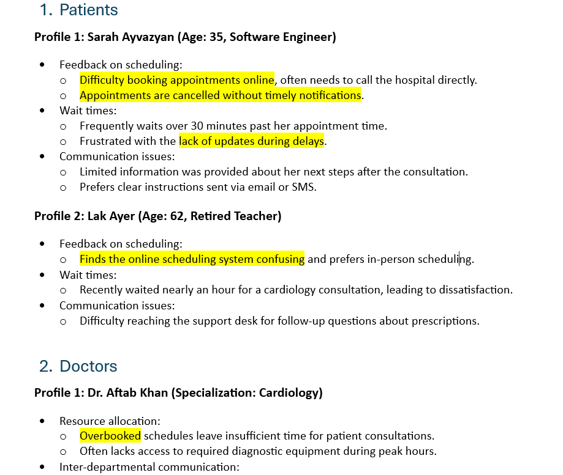

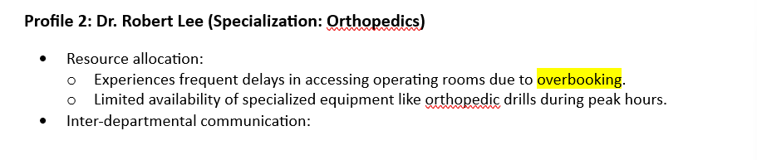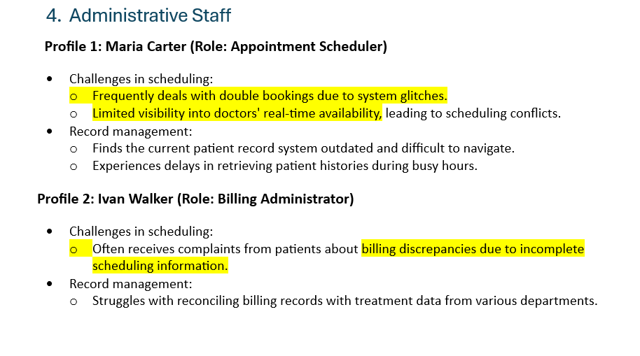
- The highlights shows that the stakeholders face conflicts while booking an appointment in App this negatively impacts user experience

Patient Feedback Trends

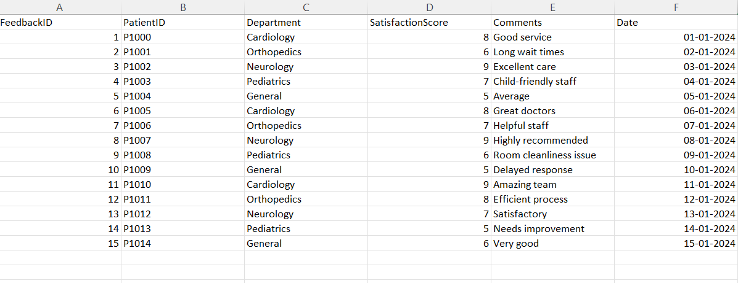

- Low satisfaction correlates with long waiting time and poor communication

Resource Utilization

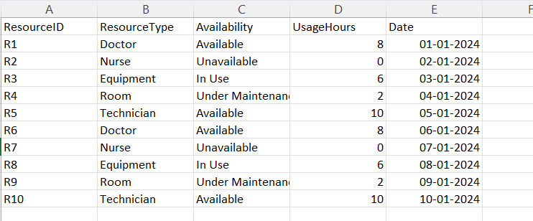

• Unavailability of nurses during nightshifts and weekends impacts both patients and other nurses working during nights shifts, causes burnout and fatigue for nurses and the rooms that are under maintenance shows that it cannot occupy any more patients. Resource shortage directly impacts patient waiting time and care delays.

Operational and Communication Gaps

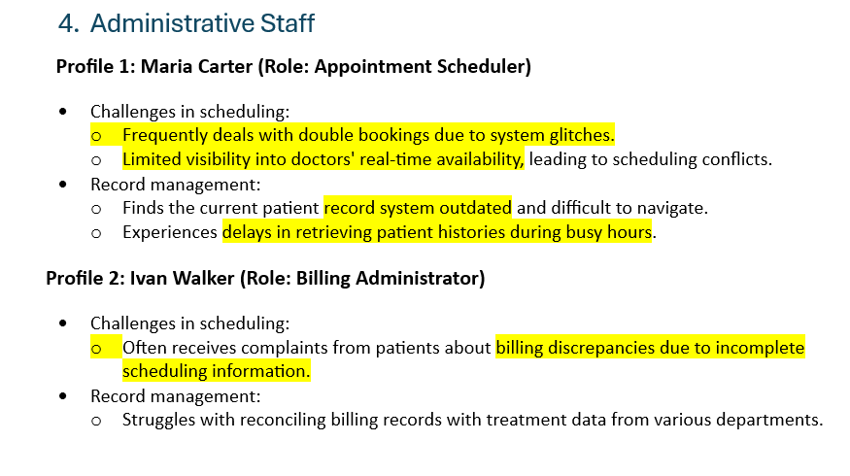
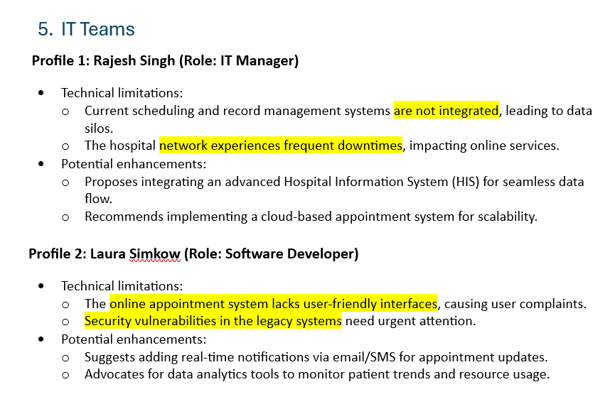

• This clearly shows the current technical gaps in the hospital, lack of integration leads to duplicate work and delays across departments.

Conclusion
- The proposed solution addresses the key challenges identified in the BRD by implementing an integrated and real-time hospital management approach. The system introduces an improved appointment scheduling module that prevents overbooking, displays real-time doctor availability, and sends timely notifications to patients regarding booking confirmations, delays, and appointment timings.

- In addition, the solution enhances resource allocation by enabling real-time tracking of hospital resources such as beds, ICUs, operation theatres, and medical equipment, supporting better planning and procurement decisions. It also improves inter-department communication, streamlines referral processes, and ensures faster access to lab results and patient records.

- Overall, the system aims to reduce patient waiting times, improve operational efficiency, and enhance the experience for patients, doctors, nurses, and administrative staff.

- Tools like Power BI and Tableau can be used to visualize patient trends and resource utilization, SQL for data analysis, and cloud platforms like Azure or Microsoft Fabric to enable real-time data processing and integration within the hospital system.

